Trinity St. Paul’s Episcopal Church, New Rochelle, New York
The 2nd Sunday of Advent: Jesse Sunday, Year C
Pledge Dedication Sunday
♦ Holy Eucharist, Rite II ♦ December 5, 2021 ♦
Liturgy from The Book of Common Prayer 1979, beginning at Page 351.

INTRODUCTION: THE PENITENTIAL ORDER
We Gather As The Community of Faith, Asking God’s Forgiveness & Help

A Welcome From Fr. Robert Gahler

Prelude

The Opening Hymn #66, The Hymnal 1982
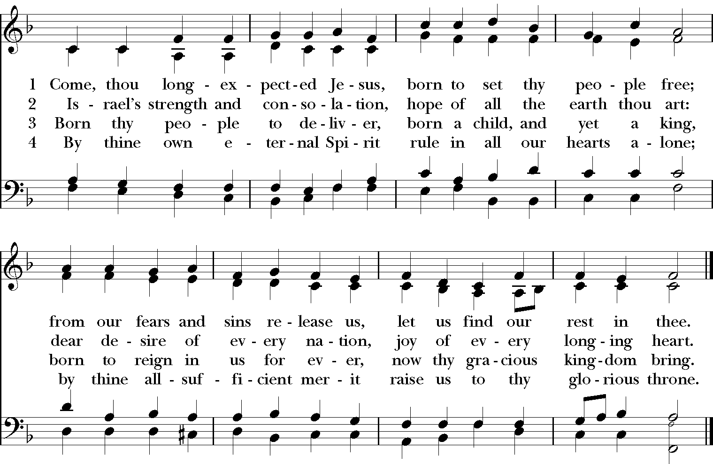
Words: Charles Wesley (1707-1788) Music: Stuttgart, melody from Psalmodia

Opening Acclamation
Celebrant: Bless the Lord who forgives all our sins.
People: God’s mercy endures for ever.

Deacon: Jesus said, “The first commandment is this: Hear, O Israel: The Lord your God is the only Lord. Love the Lord your God with all your heart, with all your soul, with all your mind, and with all your strength. The second is this: Love your neighbor as yourself. There is no commandment greater than these.” (Mark 12: 29-31)

Confession of Sin
Deacon: [Pause] Let us confess our sins against God and our neighbor.
Together: Most merciful God, we confess that we have sinned against you in thought, word, and deed, by what we have done, and by what we have left undone. We have not loved you with our whole heart; we have not loved our neighbors as ourselves. We are truly sorry and we humbly repent. For the sake of your Son Jesus Christ, have mercy on us and forgive us; that we may delight in your will, and walk in your ways, to the glory of your Name. Amen.

Celebrant: Almighty God have mercy on you, forgive you all your sins through our Lord Jesus Christ, strengthen you in all goodness, and by the power of the Holy Spirit keep you in eternal life. People: Amen.

Kyrie S-96, The Hymnal 1982
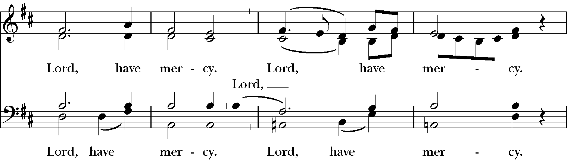
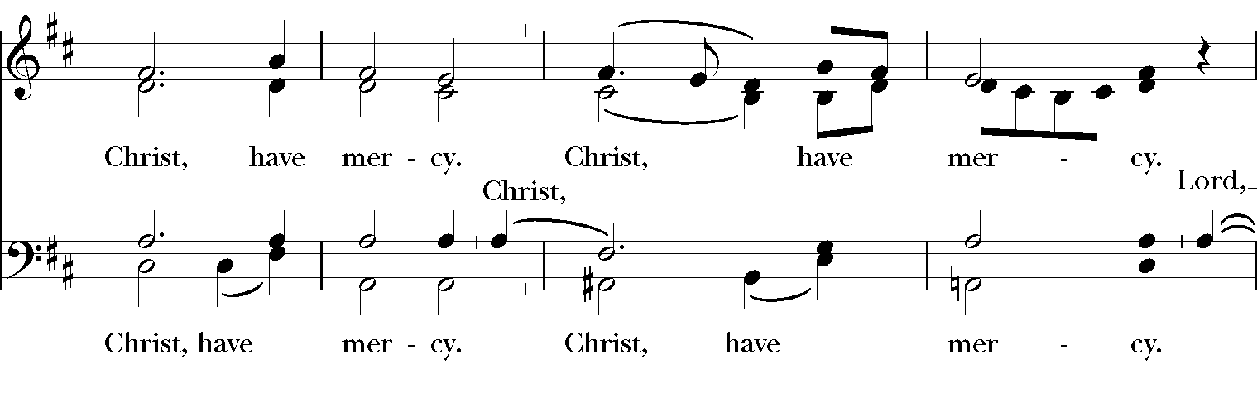
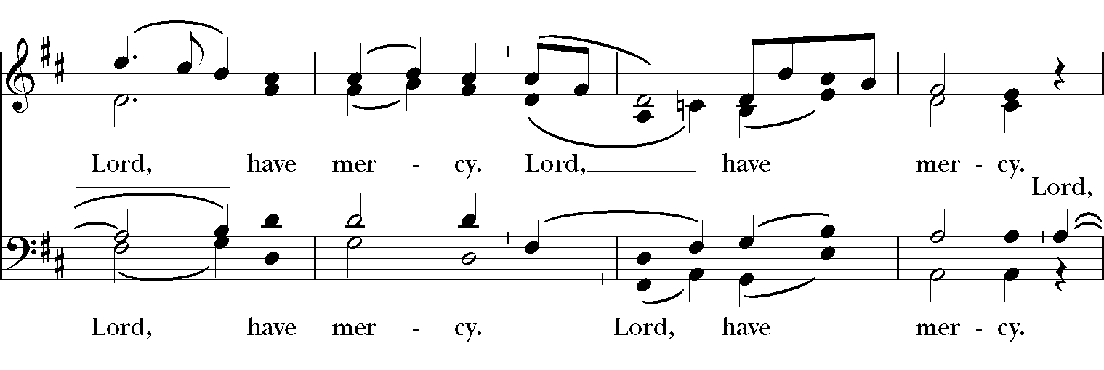
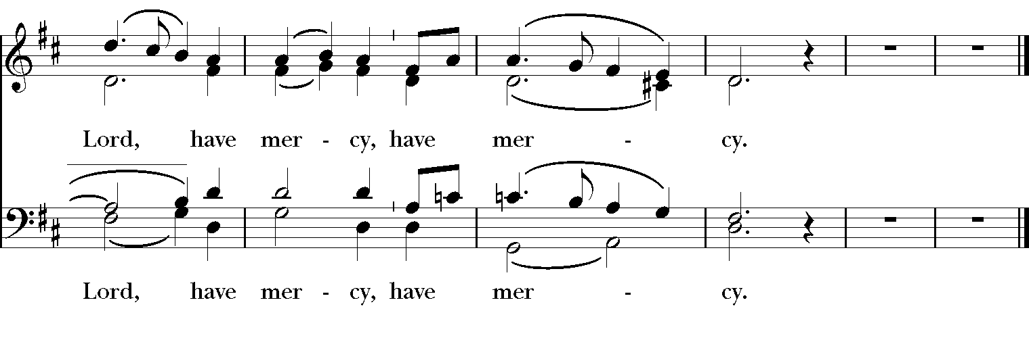

Music: From Deutsche Messe; Franz Peter Schubert (1797-1828); arr. Richard Proulx (b. 1937)

Collect of the Day: Advent II (The Book of Common Prayer, p. 211.)
Deacon: Let us pray the Collect of the Second Sunday of Advent.
Celebrant: Merciful God, who sent your messengers the prophets to preach repentance and prepare the way for our salvation: Give us grace to heed their warnings and forsake our sins, that we may greet with joy the coming of Jesus Christ our Redeemer; who lives and reigns with you and the Holy Spirit, one God, now and for ever. People: Amen.

Collect for Stewardship (The Book of Common Prayer, p. 259)
Deacon: Let us pray for our Annual Parish Stewardship Program.
Celebrant: O merciful Creator, your hand is open wide to satisfy the needs of every living creature: Make us always thankful for your loving providence; and grant that we, remembering the account that we must one day give, may be faithful stewards of your good gifts; through Jesus Christ our Lord. People: Amen.

PART ONE: LITURGY OF THE WORD
We Hear The Scripture Proclaimed And Related To Our Lives.

Hebrew Scripture Reading: Malachi 3:1-4 (Be Seated)
Lector: A Reading from the Book of Malachi.
“See, I am sending my messenger to prepare the way before me, and the Lord whom you seek will suddenly come to his temple. The messenger of the covenant in whom you delight—indeed, he is coming, says the Lord of hosts. But who can endure the day of his coming,” and who can stand when he appears? For he is like a refiner’s fire and like fullers’ soap; he will sit as a refiner and purifier of silver, and he will purify the descendants of Levi and refine them like gold and silver, until they present offerings to the Lord in righteousness. Then the offering of Judah and Jerusalem will be pleasing to the Lord as in the days of old and as in former years. Lector: The Word of the Lord. People: Thanks be to God.

Canticle 16: The Song of Zechariah (Luke 1: 68-79) (Stand) (The canticle is responsorial. The Antiphon below is sung first by the Choir; the congregation then repeats it. The canticle verses are chanted by the Choir; the congregation sings the Antiphon as indicated.)

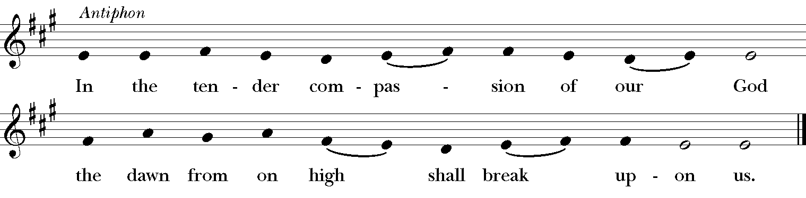

1) Blessed be the Lord, the God of Israel; *
he has come to his people and set them free.
2) He has raised up for us a mighty savior, *
born of the house of his servant David.
3) Through his holy prophets he promised of old,
that he would save us from our enemies, *
from the hands of all who hate us.
Antiphon
4) He promised to show mercy to our fathers *
and to remember his holy covenant.
5) This was the oath he swore to our father Abraham, *
to set us free from the hands of our enemies,
6) Free to worship him without fear, *
holy and righteous in his sight all the days of our life.
Antiphon
7) You, my child, shall be called the prophet of the Most High, *
for you will go before the Lord to prepare his way,

8) To give his people knowledge of salvation *
by the forgiveness of their sins.
10) To shine on those who dwell in darkness and the shadow of death, *
and to guide our feet into the way of peace.
Antiphon

Christian Scripture Reading: Philippians 1:3-11 (Be Seated)
Lector: A Reading from the Letter of Paul to the Philippians.
I thank my God every time I remember you, constantly praying with joy in every one of my prayers for all of you, because of your sharing in the gospel from the first day until now. I am confident of this, that the one who began a good work among you will bring it to completion by the day of Jesus Christ. It is right for me to think this way about all of you, because you hold me in your heart, for all of you share in God’s grace with me, both in my imprisonment and in the defense and confirmation of the gospel. For God is my witness, how I long for all of you with the compassion of Christ Jesus. And this is my prayer, that your love may overflow more and more with knowledge and full insight to help you to determine what is best, so that in the day of Christ you may be pure and blameless, having produced the harvest of righteousness that comes through Jesus Christ for the glory and praise of God. Lector: The Word of the Lord.
People: Thanks be to God.

The Alleluia and Verse #72, Songs from Taizé
(The Alleluia is responsorial. The threefold Alleluia below is sung first by the Choir; the congregation then repeats it. The Verse is chanted by the Choir alone; the threefold Alleluia is then repeated by the congregation.)

Cantor Choir, then all
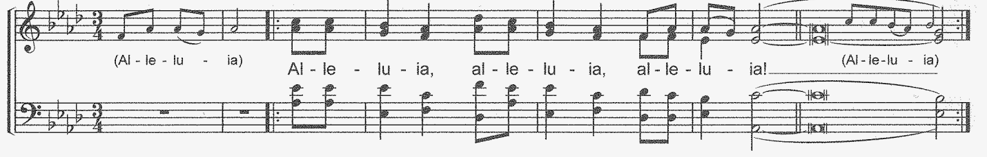

Verse: Prepare the way for the Lord; make His paths straight.
All nations shall see the salvation of God. (Isaiah 40: 3, 5)

Gospel: Luke 3:1-6
Deacon: The Holy Gospel of our Lord Jesus Christ according to Luke.
People: 
Glo – ry to you, Lord Christ.
In the fifteenth year of the reign of Emperor Tiberius, when Pontius Pilate was governor of Judea, and Herod was ruler of Galilee, and his brother Philip ruler of the region of Ituraea and Trachonitis, and Lysanias ruler of Abilene, during the high priesthood of Annas and Caiaphas, the word of God came to John son of Zechariah in the wilderness. He went into all the region around the Jordan, proclaiming a baptism of repentance for the forgiveness of sins, as it is written in the book of the words of the prophet Isaiah, “The voice of one crying out in the wilderness: ‘Prepare the way of the Lord, make his paths straight. Every valley shall be filled, and every mountain and hill shall be made low, and the crooked shall be made straight, and the rough ways made smooth; and all flesh shall see the salvation of God.’”
The Gospel of the Lord.
People: 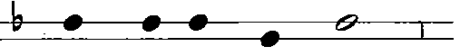
Praise to you, Lord Christ.
Sermon Fr. Robert Gahler

Nicene Creed (Sung on one note.)
We believe in one God, the Father, the Almighty, maker of heaven and earth, of all that is, seen and unseen. We believe in one Lord, Jesus Christ, the only Son of God, eternally begotten of the Father, God from God, Light from Light, true God from true God, begotten, not made, of one Being with the Father. Through him all things were made. For us and for our salvation he came down from heaven: by the power of the Holy Spirit he became incarnate from the Virgin Mary, and was made man. For our sake he was crucified under Pontius Pilate; he suffered death and was buried. On the third day he rose again in accordance with the Scriptures; he ascended into heaven and is seated at the right hand of the Father. He will come again in glory to judge the living and the dead, and his kingdom will have no end. We believe in the Holy Spirit, the Lord, the giver of life, who proceeds from the Father and the Son. With the Father and the Son he is worshiped and glorified. He has spoken through the Prophets. We believe in one holy catholic and apostolic Church. We acknowledge one baptism for the forgiveness of sins. We look for the resurrection of the dead, and the life of the world to come. Amen.

Prayers of the People (Categories of Prayer, The Book of Common Prayer, p. 383.)
Deacon: Let us pray for the needs of the Church and of the world. [Pause]
Almighty God, hear our prayers for the Church Universal, its members, and its mission.
Intercessor: Let us pray for Justin, the Archbishop of Canterbury,
For Michael, our Presiding Bishop in the Episcopal Church;
For Andrew, Allen, and Mary, our Bishops in the Diocese of New York;
For Robert, our Priest; Hyacinth and Eliza, our Deacons;
For the Wardens, Vestry & Lay Leadership of this Parish.
Cantor: People:
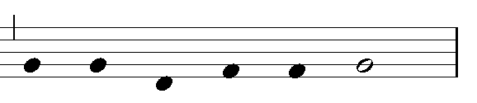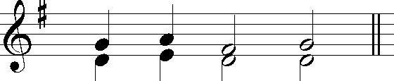
Let us pray to the Lord Lord hear our prayer
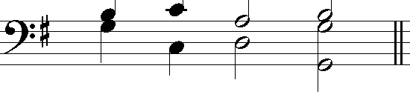 Music: S-106, The Hymnal 1982

Deacon: O God, our Sustainer, inspire our efforts to serve in your name.
Intercessor: Let us pray for our Parish Outreach Programs; especially our “Brown Bag” Lunch
Program.
Cantor: Let us pray to the Lord. People: Lord, hear our prayer.
Deacon: O God our Governor, hear our prayers for the world, our nation,
and all in authority.
Intercessor: We pray for Joseph our President and Kamala our Vice President; for the
members of Congress, and the members of the Supreme Court; that they may work for justice, equal opportunity and civil rights in our nation. For Antonio, the Secretary-General of the United Nations, and for the leaders of the Member States; that they all may work for peace and
international cooperation.
Cantor: Let us pray to the Lord. People: Lord, hear our prayer.

Deacon: O God our Creator, hear our prayers for the welfare of the world.
Intercessor: We pray for peace with justice in Yemen, Syria, Libya, Sudan, Myanmar,
and all other areas torn by violence.
We pray for the care of God’s creation; especially for God’s guidance in the installation of the new heating and cooling system here in church.
Cantor: Let us pray to the Lord. People: Lord, hear our prayer.

Deacon: Most Gracious God, we pray sharing the thanksgivings and concerns of our
local community.
Intercessor: We give thanks for those in the parish celebrating Birthdays from December 5th
through December 11th: Odih Ewoterai, Berkley Taylor, Deji Soyeju, Udo Okeke,
Mazi Sigmond, Sean Patrick Gahler Hull, and Deidre Henry.
We give thanks for, and we pray for, our Homebound Parishioners: Henry Cadogan, Elsie
Chatman, Lorma Davis, Lecent Gittens, Iris Cassis, Iris Wilkinson, Dorothy June Schetterer, Hazel Mair, Olive Vaughan, and Pearl Carter.
Cantor: Let us pray to the Lord. People: Lord, hear our prayer.

Deacon: Most Merciful God, we pray for those who are sick or in need.
Intercessor: We pray for Warren, Joseph, Mary Alice, Sheila, Philip, Kamden, Alease,
Ruth, Stafford, Tim, Ray, Anthony, Stewart, Yvonne, Gloria, David, Olufemi, Bill, Judy, Windell, Robert, and Jodie.
We also pray for all who suffer from the Covid-19 virus and for their families, friends,
and medical care givers. We pray for those who are unemployed, and for businesses
that have closed, because of the pandemic.
We pray for all who continue to suffer because of the hurricanes and forest fires.
We pray for the people of Afghanistan amid the military and political turbulence there,
and we pray especially for those struggling to leave the country in fear for their lives.
We pray for the people of Haiti suffering still from the earthquake and tropical storms.
Cantor: Let us pray to the Lord. People: Lord, hear our prayer.

Deacon: Most Loving God, we pray for the departed.
Intercessor: We pray for Henrietta Gahler, Catherine Toohey, Patrick Erlandson, Joseph
DiBartolo, Adeola Agbontaen, Leonor Suarez-Taylor, Will Santiago, Nancy Ward, Sylvia Byrd, Julian Carmichael, Hicham Belkadi, Justina Uruakpa, Rae Eli, Sean Hoyte, the Rev. Dr. Michael Ajari, Horace Thompson, Richard Francis, and for those we love who have died, especially those who have died in this past year.
We pray for those who have died because of the hurricanes and forest fires.
We pray for who have died from the Covid-19 virus. May they all rest in peace.
Cantor: Let us pray to the Lord. People: Lord, hear our prayer.

Concluding Collect: For the Poor and the Neglected (Book of Common Prayer, Pg. 826, #35)
Deacon: Let us pray for the Poor and the Neglected.
Celebrant: Almighty and most merciful God, we remember before you all poor and neglected people whom it would be easy for us to forget: the homeless and the destitute, the old and the sick, and all who have none to care for them. Help us to heal those who are broken in body or spirit, and turn their sorrow into joy. Grant this, Father, for the love of your Son, who for our sake became poor, Jesus Christ our Lord. People: Amen.

PART TWO: THE DEDICATION OF OUR 2022 ANNUAL PLEDGES
(Form of Dedication, The Book of Occasional Services 2003, pages 212-213)

Deacon: If you sent your 2022 Pledge to the Parish Office, it is in the basket this morning to be blessed. If you have not turned in your 2022 Pledge to the Ushers, please get one from the Ushers now and give it to the Vestry Members as they come forward during this Hymn. Please stand for our Hymn of Thanksgiving & Dedication.

Hymn At The Dedication #107, Voices Found: Women in the Church’s Song
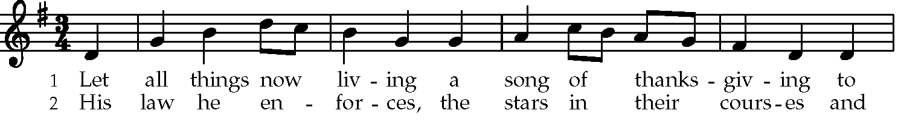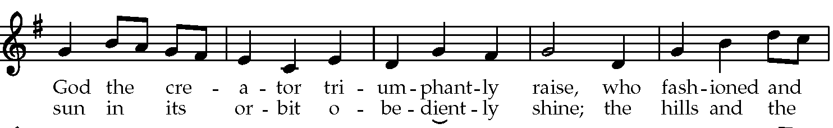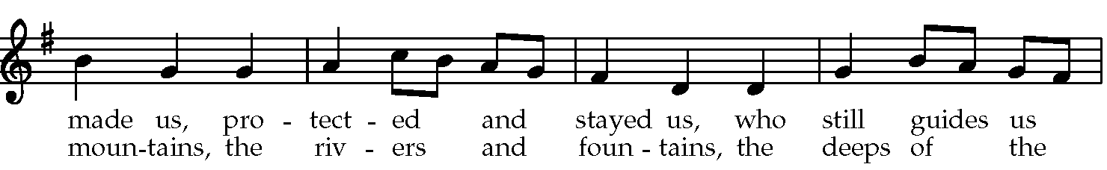
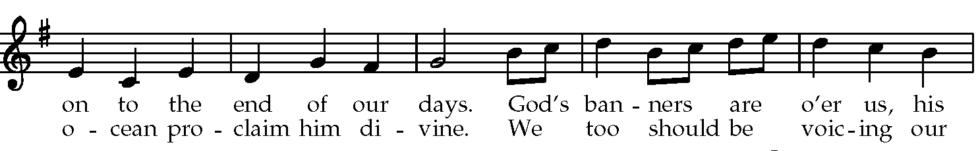
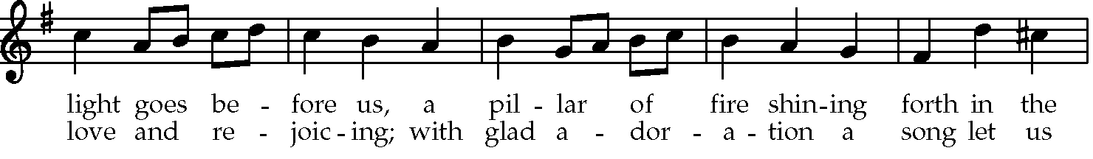
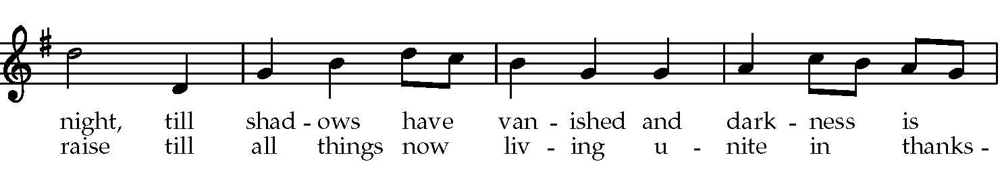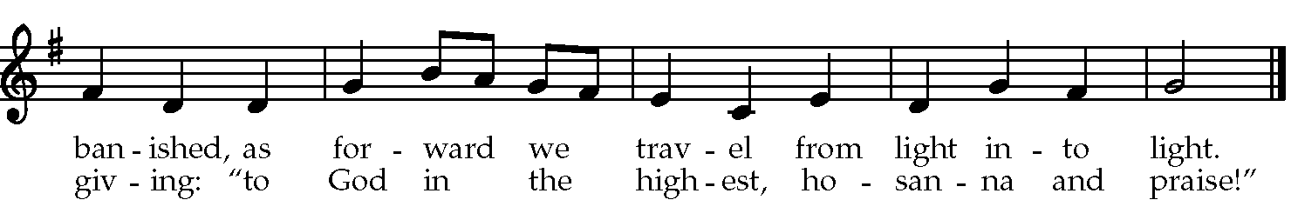
Words: Katherine K. Davis (1892-1980) Music: The Ash Grove, Welsh folk tune.

Vestry Members: We present to you these Annual Pledges to the life and mission of Trinity St. Paul’s Parish to be set apart for the service of Christ’s holy Church.

Deacon: All things come from you, O Lord;
People: And from your own gifts do we give to you.
Deacon: Prosper the work of our hands;
People: Prosper our handiwork.
Deacon: Show your servants your works;
People: And your splendor to their children.
Deacon: Almighty God, we thank you that you have put it into the hearts of your people to make offerings for your service, and have been pleased to accept their gifts. Be with us now and bless us as we set apart these 2022 Annual Pledges to your praise and glory; through Jesus Christ our Lord. People: Amen.

Prayer of Dedication
Celebrant: O God, whose blessed Son has sanctified and transfigured the use of material things: Receive and bless (+) these 2022 Annual Pledges, and those yet to be given, which we offer for your mission in this Parish, in the Diocese, in the Nation, and in the World; and grant that they may proclaim your love, benefit your Church, and minister grace and joy to your people; through Jesus Christ our Lord. People: Amen.

Prayer For Our Benefactors
Celebrant: We bless your Name, O Lord, because it has pleased you to enable your servants to offer gifts for your Church. Remember them in your love, and grant them your true peace and joy; through Jesus Christ our Lord, who lives and reigns with you and the Holy Spirit, one God, now and for ever. People: Amen.

The Peace (Please share a sign of Christ’s peace.) Announcements (Be seated)

PART TWO: THE LITURGY OF THE EUCHARIST
We Follow Jesus’ Example In Giving Thanks & Blessing.
We Offer God All Of Ourselves & Receive Back True Nourishment.

THE OFFERTORY [Action One by Jesus at the Last Supper: Jesus Took Bread & Wine]
[Action One by Jesus at the Last Supper: Jesus Took Bread & Wine
“Comfort, Comfort Ye My People” - David Ashley White (born 1944)

Trinity St Paul’s Parish Choir
Section Leaders: Linda Bottos, Soprano; Shane Brown, Baritone

Comfort, comfort ye my people, Hark, the voice of one that crieth
speak ye peace, thus saith our God. in the desert far and near,
Comfort those who sit in darkness calling us to new repentance
mourning ‘neath their sorrows load. since the kingdom now is here.
Speak ye to Jerusalem Oh, that warning cry obey!
of the peace that waits for them; Now prepare for God a way;
tell her that her sins I cover, let the valleys rise to meet Him
and her warfare now is over. and the hills bow down to greet Him.

Make ye straight what once was crooked,
make the rougher places plain,
O let your hearts be true and humble,
as befits His holy reign.
For the glory of the Lord
now o’er earth is shed abroad;
and all flesh shall see the token
that the word is never broken.
Text: Isaiah 40: 1-5; versification by Johann G. Loearious (1671), as translated by Catherine Winkworth (1863)
Sursum Corda S-120, The Hymnal 1982
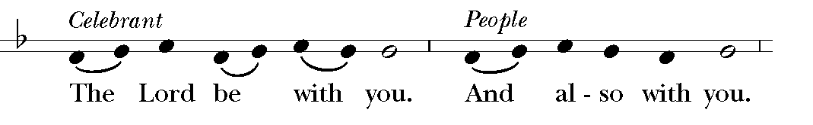
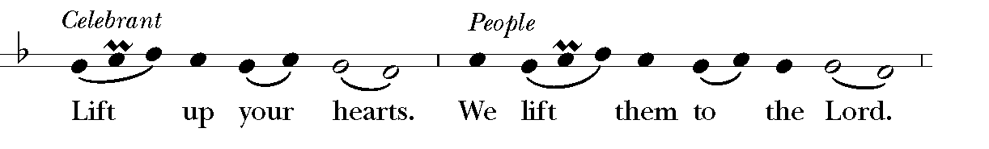
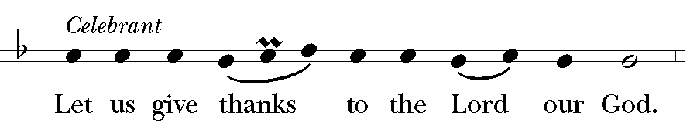
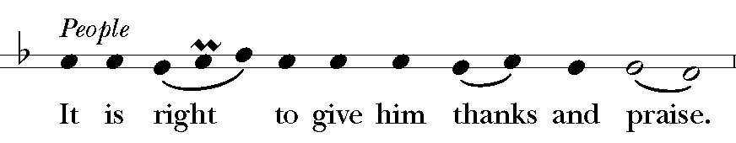

It is right, and a good and joyful thing, always and everywhere to give thanks to you, Father Almighty, Creator of heaven and earth. Because you sent your beloved Son to redeem us from sin and death, and to make us heirs in him of everlasting life; that when he shall come again in power and great triumph to judge the world, we may without shame or fear rejoice to behold his appearing. Therefore we praise you, joining our voices with Angels and Archangels and with all the company of heaven, who for ever sing this hymn to proclaim the glory of your Name:

Sanctus S-130, The Hymnal 1982
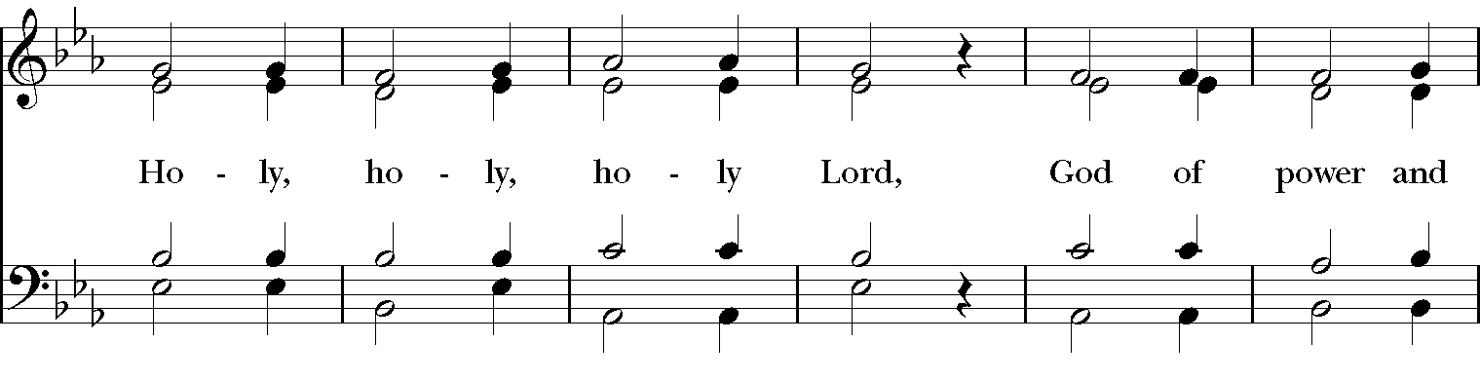
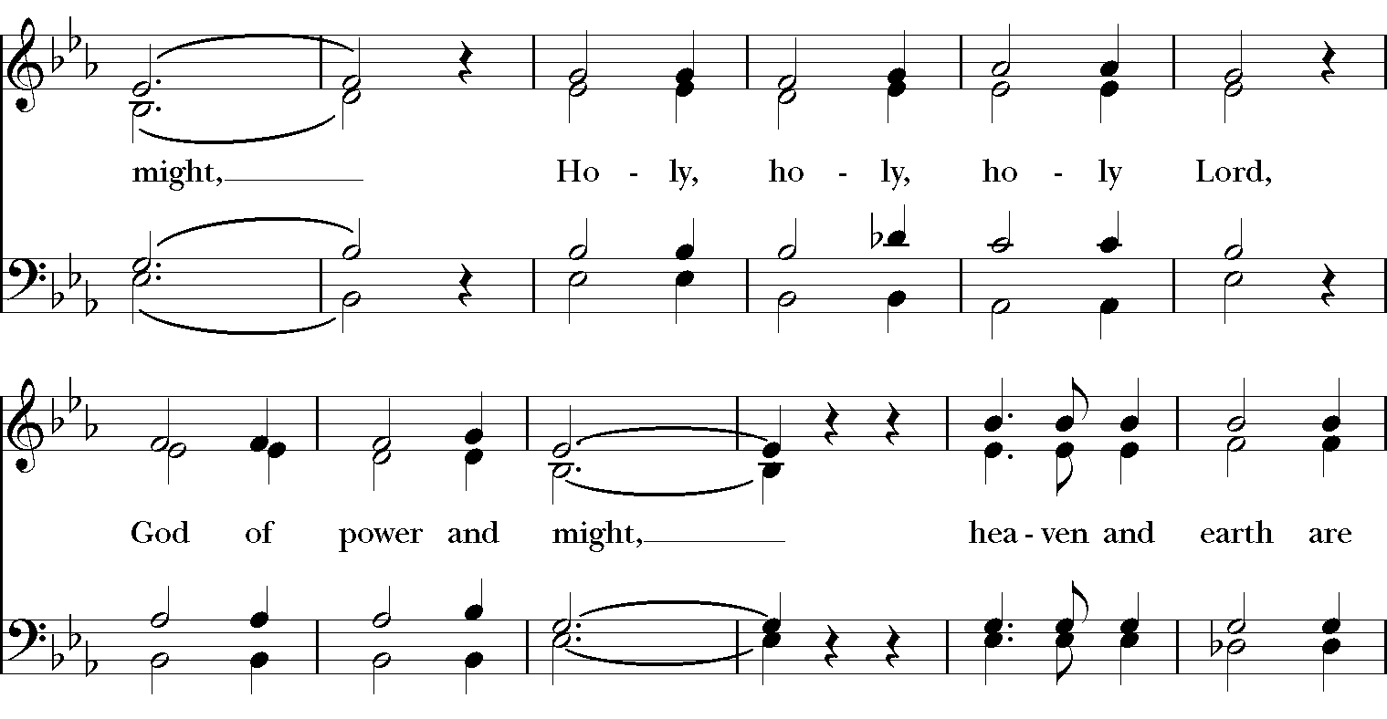
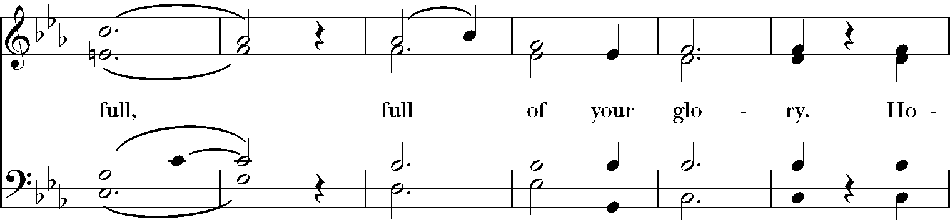
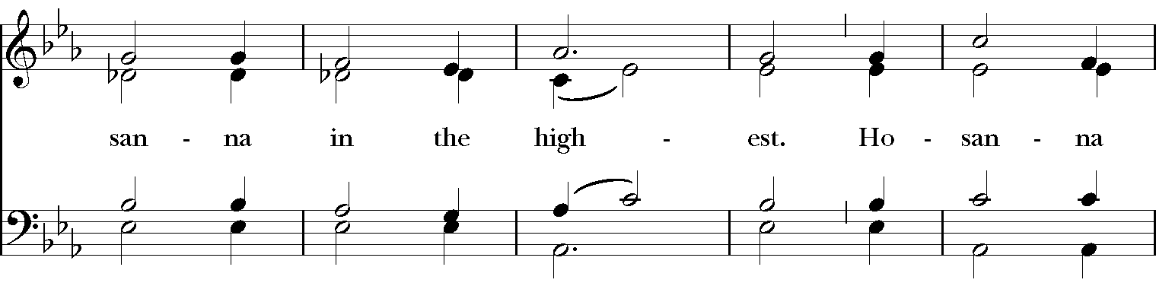
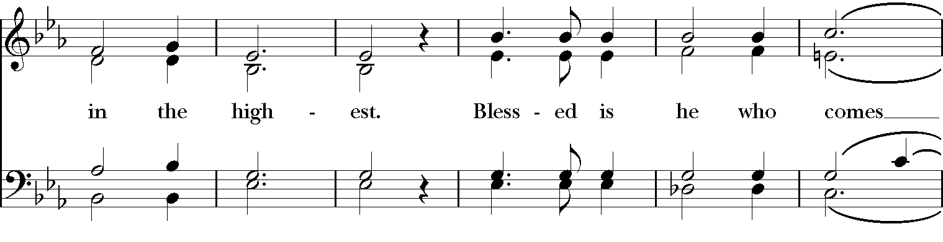
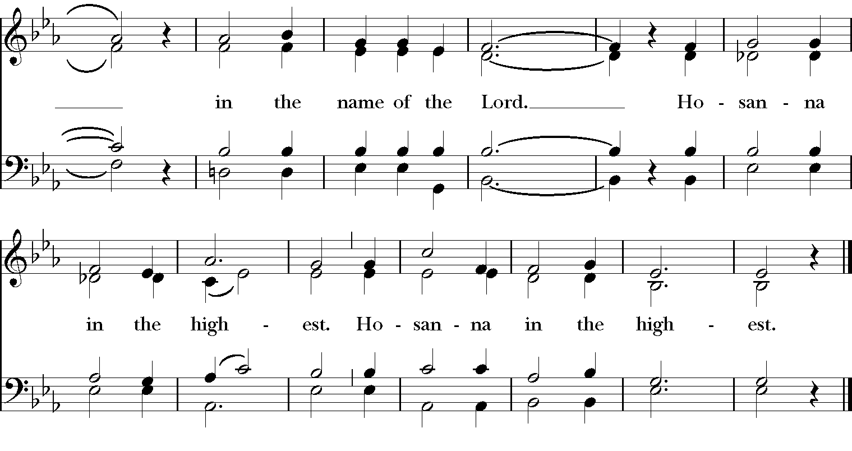

Music: From Deutsche Messe, Franz Peter Schubert (1797-1828); arr. Richard Proulx (b. 1937)

Celebrant: Holy and gracious Father: In your infinite love you made us for yourself, and, when we had fallen into sin and become subject to evil and death, you, in your mercy, sent Jesus Christ, your only and eternal Son, to share our human nature, to live and die as one of us, to reconcile us to you, the God and Father of all. He stretched out his arms upon the cross, and offered himself, in obedience to your will, a perfect sacrifice for the whole world.

On the night he was handed over to suffering and death, our Lord Jesus Christ took bread; and when he had given thanks to you, he broke it, and gave it to his disciples, and said, “Take, eat: This is my Body, which is given for you. Do this for the remembrance of me.”

After supper he took the cup of wine; and when he had given thanks, he gave it to them, and said, “Drink this, all of you: This is my Blood of the new Covenant, which is shed for you and for many for the forgiveness of sins. Whenever you drink it, do this for the remembrance of me.”

Therefore we proclaim the mystery of faith:
Celebrant and People: Christ has died. Christ is risen. Christ will come again.

Celebrant: We celebrate the memorial of our redemption, O Father, in this sacrifice of praise and thanksgiving. Recalling his death, resurrection, and ascension, we offer you these gifts.

Sanctify them by your Holy Spirit to be for your people the Body and Blood of your Son, the holy food and drink of new and unending life in him. Sanctify us also that we may faithfully receive this holy Sacrament, and serve you in unity, constancy, and peace; and at the last day bring us with all your saints into the joy of your eternal kingdom.

All this we ask through your Son Jesus Christ: By him, and with him, and in him, in the unity of the Holy Spirit all honor and glory is yours, Almighty Father, now and for ever.

#617b, With One Voice
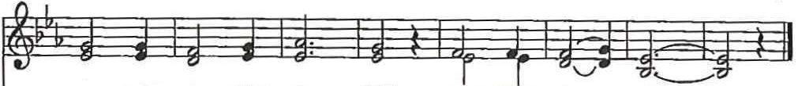
A - men, a - men, a - men. A - men, a - men.
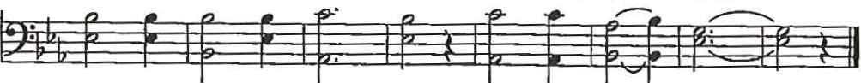
Music: Deutsche messe, Franz Schubert, 1797-1828, adapt.

The Lord’s Prayer (Contemporary Version) S-148, The Hymnal1982
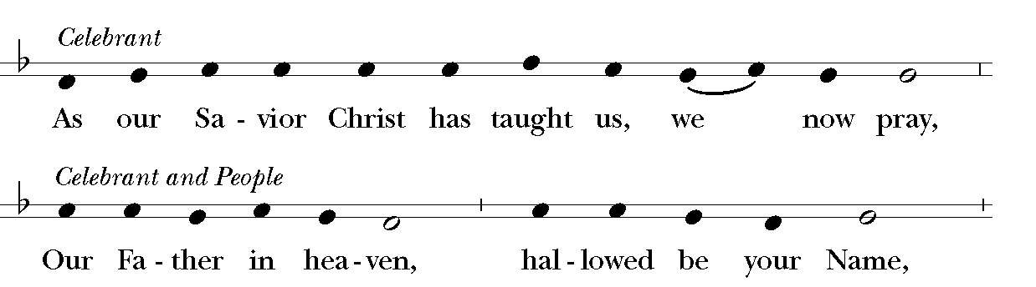
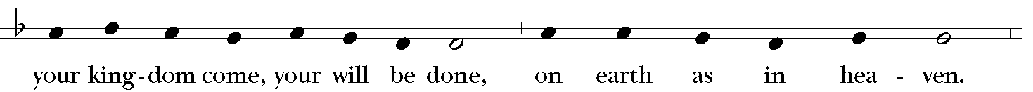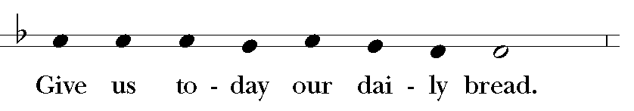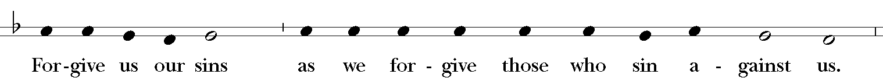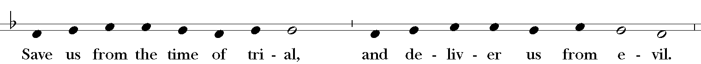
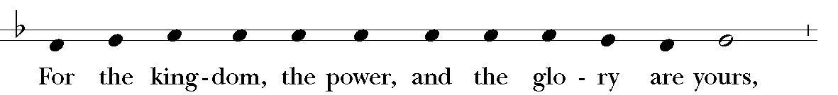
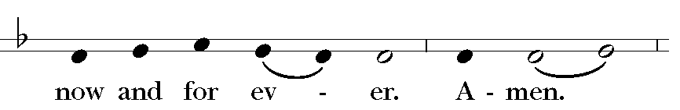 Music: Ambrosian chant; adapt. Mason Martens (1933-1991)

THE BREAKING OF THE BREAD [Action Three: Jesus Broke The Bread]
Celebrant: Alleluia. Christ our Passover is sacrificed for us;
People: Therefore let us keep the feast. Alleluia

Fraction Anthem: S-164, the Hymnal 1982
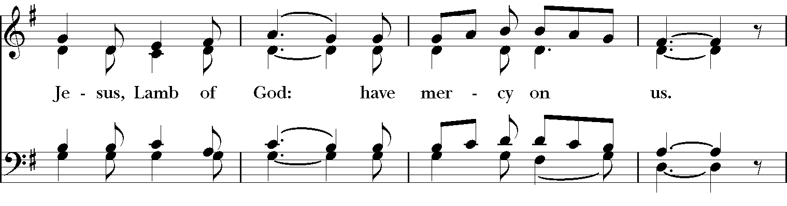
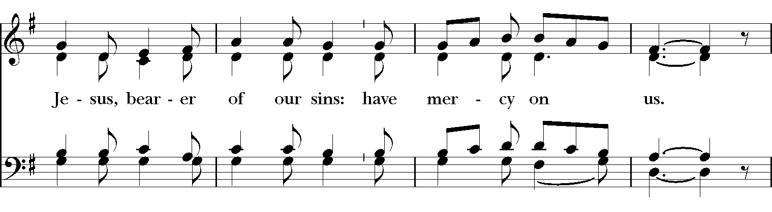

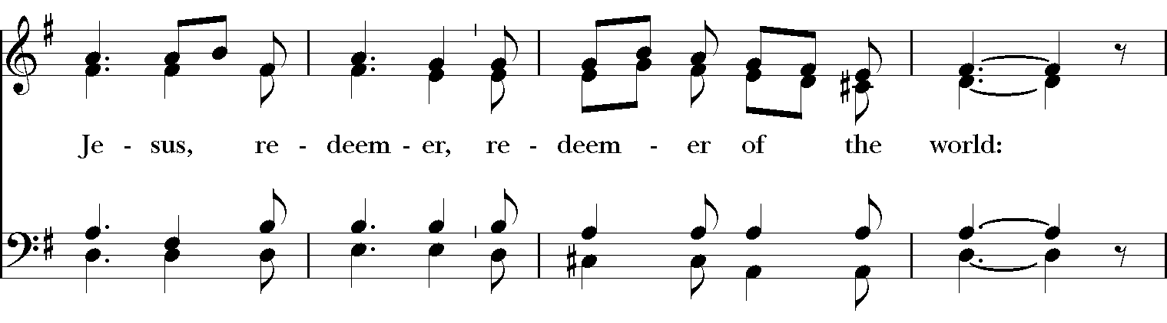
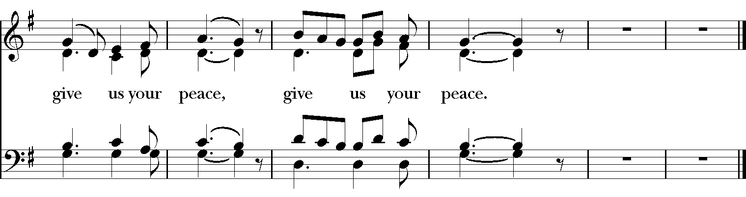
Music: From Deutsche Messe; Franz Peter Schubert (1797-1828); arr. Richard Proulx (b. 1937)

Celebrant: The Gifts of God for the People of God. Take them in remembrance that Christ died for you, and feed on him in your hearts by faith, with thanksgiving.

THE COMMUNION [Action Four: Jesus Gave The Bread & Wine]
(Those who are gathered in the parish church receive Communion on behalf of those participating electronically because of the pandemic.)

The Book of Common Prayer Assures of Full Spiritual Communion: “If a person desires to receive the Sacrament, but, by reason of extreme sickness or disability, is unable to eat or drink the Bread or Wine, the Celebrant is to assure that person that all of the benefits of Communion are received, even though the Sacrament is not received with the mouth.” (BCP, p 457)

A Prayer By Those Unable To Receive Communion Physically: Blessed Jesus, I believe that you are truly present in the Holy Sacrament, and, since I cannot at this time receive communion, I pray you to come into my heart. I unite myself with you and embrace you with all my heart, my soul, and my mind. Let nothing separate me from you; let me serve you in this life until, by your grace, I come to your glorious kingdom and unending peace. Amen.



THE CONCLUDING RITE
We Are Sent Forth To Serve All People In Christ’s Name.

Post Communion Prayer
Celebrant: Let us pray.
Celebrant & People: Eternal God, heavenly Father, you have graciously accepted us as living members of your Son our Savior Jesus Christ, and you have fed us with spiritual food in the Sacrament of his Body and Blood. Send us now into the world in peace, and grant us strength and courage to love and serve you with gladness and singleness of heart; through Christ our Lord. Amen.

Blessing

Closing Hymn #72, The Hymnal 1982
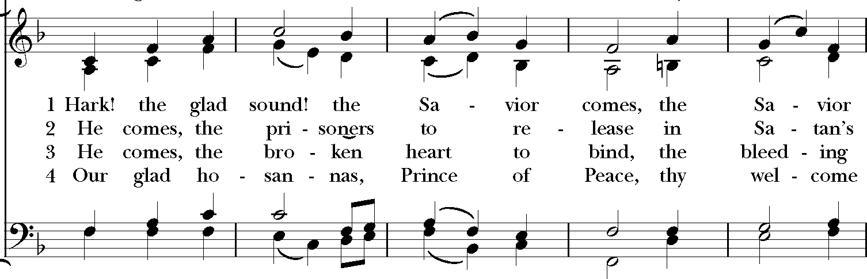
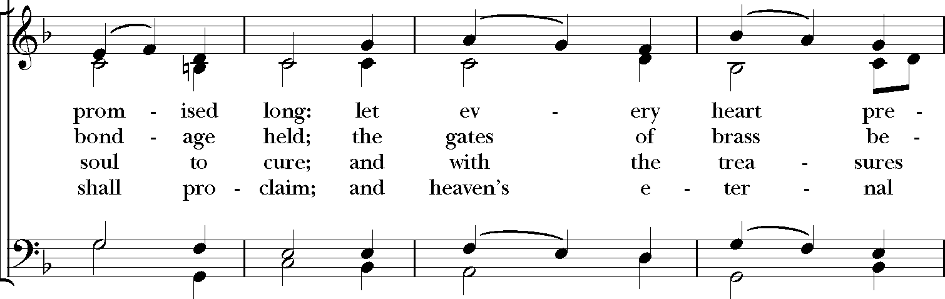
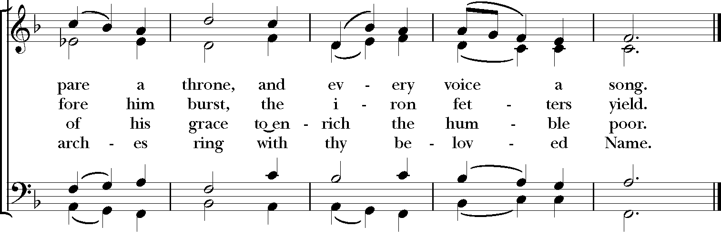
Words: Philip Doddridge (1702-1751) Music: Richmond, melody Thomas Haweis (1734-1820); adapt. Samuel Webbe (1740-1816); harm. Hymns Ancient and Modern, Revised, 1950; desc. Craig Sellar Lang (1891-1971)

Dismissal: S-174, The Hymnal 1982
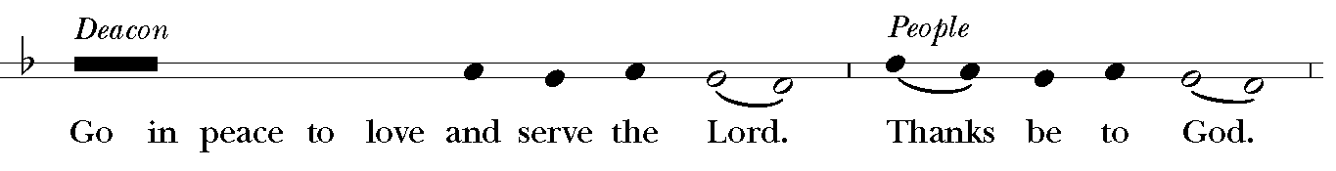

Postlude

Ministers of the Day
Celebrant & Preacher The Rev. Robert E. Gahler
Deacon The Rev. Hyacinth E. Lee
Organist & Director of Parish Music Philip Auman Godlewski
Trinity St. Paul’s Singers Royaline Bailey (Soprano), Traci Moser (Soprano),
Michael Hull (Tenor), Robert Puleo (Tenor),
Philip Auman Godlewski (Baritone)
Lector Rose-Marie Gomes
Intercessor Robert Puleo
Acolyte Sean Patrick Gahler Hull
Boat Bearer Olivia Moser
Ushers Pat Nelson, Sookie Eli
Video Michael Hull, Delano Allen, Sean Patrick Gahler Hull



