Trinity St. Paul’s Episcopal Church, New Rochelle, New York
Holy Cross Sunday: The Parish Feast of Dedication
The 333rd Anniversary of the Parish
The 158th Anniversary of the Opening of this Church Building
The 140th Anniversary of the Consecration of this Church Building.
(The 17th Sunday After Pentecost: Proper 20, Year B)
♦ Holy Eucharist, Rite II ♦ September 19, 2021 ♦ 10:30 am
Liturgy from The Book of Common Prayer 1979, beginning at Page 355.

INTRODUCTION: THE ENTRANCE RITE
We Gather As The Community of Faith, In God’s Name
A Welcome From Fr. Robert Gahler

Organ Prelude

Opening Hymn #360, The Hymnal 1982
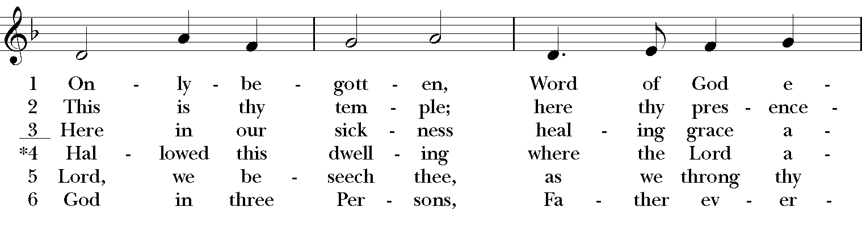
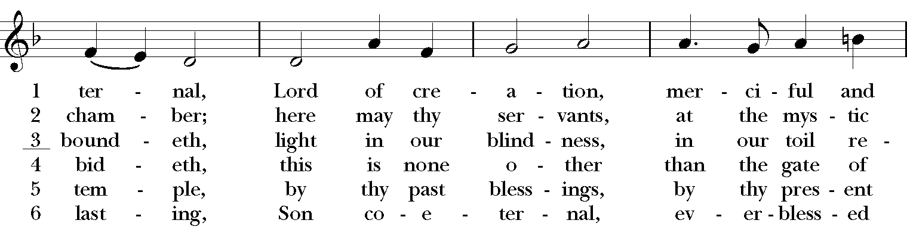
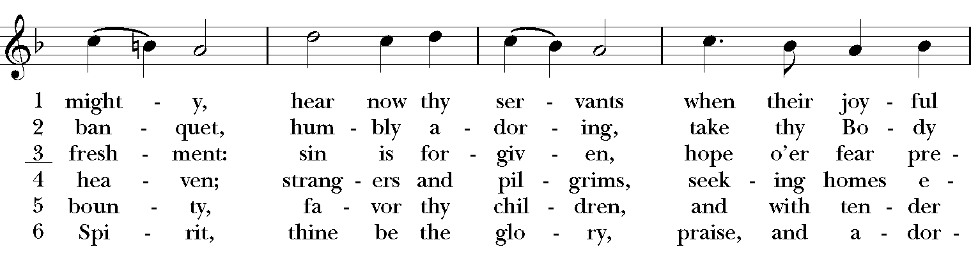
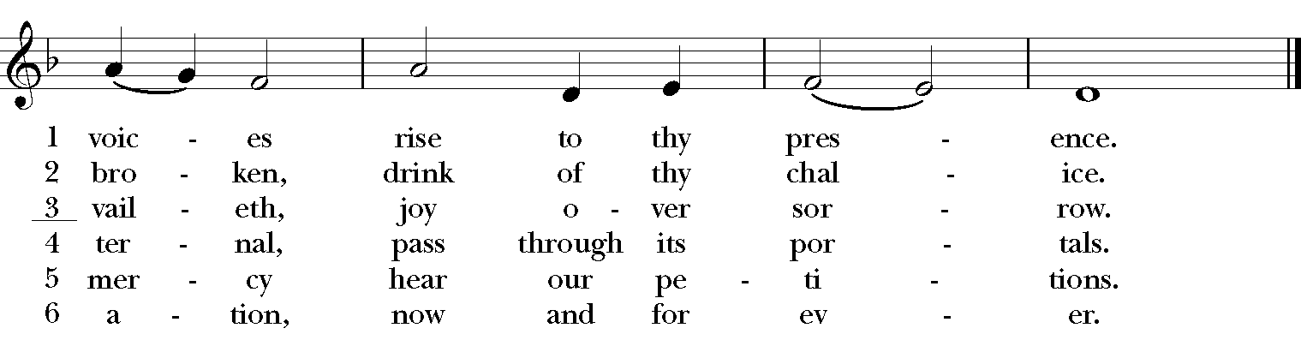
Words: Latin, ca. 9th cent.; tr. Maxwell Julius Blacker (1822-1888)
Music: Rouen, melody from Vesperale, 1746; harm. Healey Willan (1880-1968)
Celebrant: Blessed be God: Father, Son, and Holy Spirit.
People: And blessed be God’s kingdom, now and forever. Amen.

Collect of the Day for Holy Cross Sunday (BCP, Page 244.)
Deacon: Let us pray the Collect of the Day for Holy Cross Sunday.
Celebrant: Almighty God, whose Son our Savior Jesus Christ was lifted high upon the cross that he might draw the whole world to himself: Mercifully grant that we, who glory in the mystery of our redemption, may have grace to take up our cross and follow him, your Son Jesus Christ our Lord. People: Amen.

Collect of the Anniversary of the Founding of this Parish (BCP, Page 254.)
Deacon: Let us pray on the Anniversary of the Founding of this Parish.
Celebrant: Almighty God, to whose glory we celebrate the 333rd Anniversary of the founding of this Parish: We give you thanks for the fellowship of those who have worshiped in this community, and we pray that all who seek you here may find you, and be filled with your joy and peace; through Jesus Christ our Lord, who lives and reigns with you, in the unity of the Holy Spirit, one God, now and for ever. People: Amen.

Collect for the Parish (The Book of Common Prayer, Page 817.)
Deacon: Let us pray for our Parish.
Celebrant: Almighty and everliving God, ruler of all things in heaven and on earth, hear our prayers for our Trinity St. Paul’s Parish Family. Strengthen the faithful, arouse the careless, restore the penitent. Grant us all things necessary for our common life, and bring us all to be of one heart and mind within your holy Church; through Jesus Christ our Lord. People: Amen.
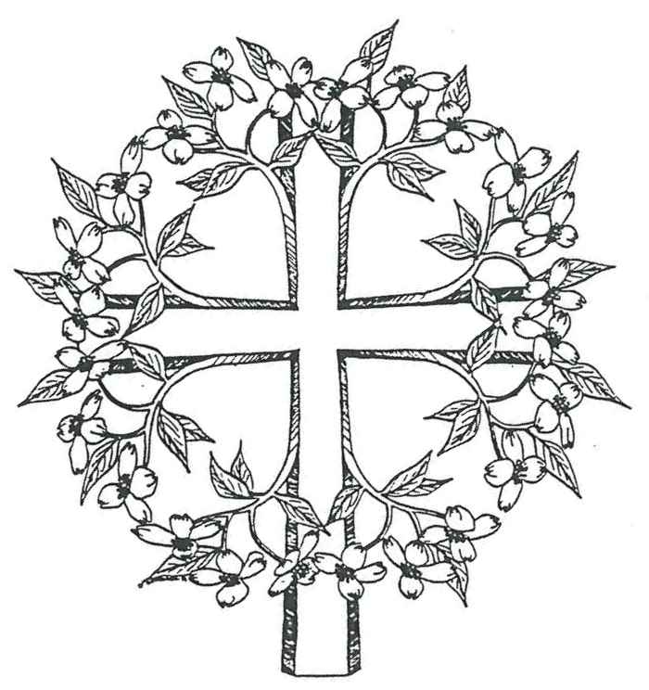
PART ONE: LITURGY OF THE WORD
We Hear The Scripture Proclaimed And Related To Our Lives.

Hebrew Scripture Reading: Isaiah 45: 21-25

Lector: A Reading from the Book of the Prophet Isaiah
Thus says the Lord, “Declare and present your case; let them take counsel together! Who told this long ago? Who declared it of old? Was it not I, the Lord? There is no other god besides me, a righteous God and a Savior; there is no one besides me. Turn to me and be saved, all the ends of the earth! For I am God, and there is no other. By myself I have sworn, from my mouth has gone forth in righteousness a word that shall not return: ‘To me every knee shall bow, every tongue shall swear.’ Only in the Lord, it shall be said of me, are righteousness and strength; all who were incensed against him shall come to him and be ashamed. In the Lord all the offspring of Israel shall triumph and glory.” Lector: The Word of the Lord. People: Thanks be to God.

Psalm 98:1-4 (The psalm is responsorial. The refrain below is sung first by the Cantors; the congregation then repeats it. The psalm verses are chanted by a Cantors alone; the refrain is then sung by all as indicated.)
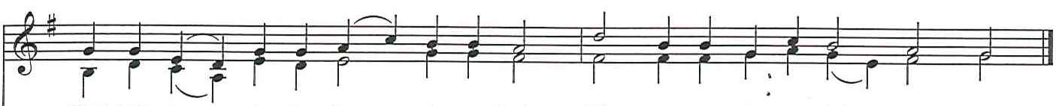
Shout with joy__ to the Lord,___ all you lands; lift up your voice, re- joice__ and sing
1 Sing to the Lord a new song, *
for he has done marvelous things.
2 With his right hand and his holy arm *
has he won for himself the victory.
Refrain
3 The Lord has made known his victory; *
his righteousness has he openly shown in the sight of the nations.
4 He remembers his mercy and faithfulness to the house of Israel, *
and all the ends of the earth have seen the victory of our God.
Refrain

Christian Scripture Reading: Galatians 6:14-18
Lector: A Reading from the Letter to the Galatians.
May I never boast of anything except the cross of our Lord Jesus Christ, by which the world has been crucified to me, and I to the world. For neither circumcision nor uncircumcision is anything; but a new creation is everything! As for those who will follow this rule—peace be upon them, and mercy, and upon the Israel of God. From now on, let no one make trouble for me; for I carry the marks of Jesus branded on my body. May the grace of our Lord Jesus Christ be with your spirit, brothers and sisters. Amen. Lector: The Word of the Lord.
People: Thanks be to God.

Alleluia at the Sequence (The threefold "Alleluia" is sung first by a Cantor, the congregation then repeats it. The Gradual Verse appropriate to the day is then chanted by a Cantor; the threefold "Alleluia" is then repeated by all.)
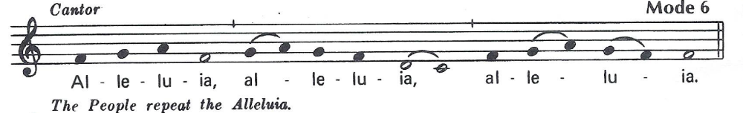

Gradual Verse: “When I am lifted up from the earth, I will draw all people to myself.”

Gospel: John 12:31-36a
Deacon: The Holy Gospel of our Lord Jesus Christ according to John.
People: 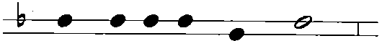
Glo – ry to you, Lord Christ.
Deacon: Jesus said, “Now is the judgment of this world; now the ruler of this world will be driven out. And I, when I am lifted up from the earth, will draw all people to myself.” He said this to indicate the kind of death he was to die. The crowd answered him, “We have heard from the law that the Messiah remains forever. How can you say that the Son of Man must be lifted up? Who is this Son of Man?” Jesus said to them, “The light is with you for a little longer. Walk while you have the light, so that the darkness may not overtake you. If you walk in the darkness, you do not know where you are going. While you have the light, believe in the light, so that you may become children of light.” The Gospel of the Lord.
People: 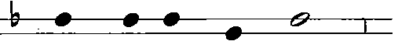
Praise to you, Lord Christ.

Sermon Fr. Robert Gahler

Nicene Creed (Sung on one note.)
We believe in one God, the Father, the Almighty, maker of heaven and earth, of all that is, seen and unseen. We believe in one Lord, Jesus Christ, the only Son of God, eternally begotten of the Father, God from God, Light from Light, true God from true God, begotten, not made, of one Being with the Father. Through him all things were made. For us and for our salvation he came down from heaven: by the power of the Holy Spirit he became incarnate from the Virgin Mary, and was made man. For our sake he was crucified under Pontius Pilate; he suffered death and was buried. On the third day he rose again in accordance with the Scriptures; he ascended into heaven and is seated at the right hand of the Father. He will come again in glory to judge the living and the dead, and his kingdom will have no end. We believe in the Holy Spirit, the Lord, the giver of life, who proceeds from the Father and the Son. With the Father and the Son he is worshiped and glorified. He has spoken through the Prophets. We believe in one holy catholic and apostolic Church. We acknowledge one baptism for the forgiveness of sins. We look for the resurrection of the dead, and the life of the world to come. Amen.

Prayers of the People (Litany of Thanksgiving for a Church, BCP, p 578, augmented.)
Deacon: Let us pray for the needs of the Church and of the World.[Pause]

Deacon: We thank you Lord for all the Blessings of this life.
We give thanks for the life and ministry of Trinity St. Paul’s on its 333rd Anniversary, in
whose honor the Altar Flowers are given, and the Sanctuary Lamp burns this week.
We give thanks for those in the parish celebrating Birthdays from September 19th through
September 25th: Eli Marin Ward.
We give thanks for, and we pray for, our Homebound Parishioners: Henry Cadogan,
Elsie Chatman, Lorma Davis, Lecent Gittens, Iris Cassis, Iris Wilkinson, Dorothy June
Schetterer, Hazel Mair, Olive Vaughan, and Pearl Carter.
Deacon: We will exalt you, O God our King;
People: And Praise your Name for ever and ever.

Deacon: Let us pray for those who are sick or in need: Warren, Joseph, Mary Alice, Sheila,
Philip, Kamden, Alease, Maurice, Ruth, Stafford, Tim, Ray, Anthony, Rhonald, Robert, Stewart, Henry, Yvonne, Gloria, Jacob, David, Rae, and Leah.
We also pray for all who suffer from the Covid-19 virus and for their families, friends,
and medical care givers. We pray for those who are unemployed, and for businesses
that have closed, because of the pandemic.
We pray for all who suffer because of the hurricanes and forest fires.
We pray for the people of Afghanistan amid the military and political turbulence there,
and we pray especially for those struggling to leave the country in fear for their lives.
We pray for the people of Haiti suffering from the earthquake and tropical storms.
Deacon: Hear us O Lord;
People: For your mercy is great.

Deacon: We pray for all who have died, that they may have a place in your eternal kingdom.
We pray for Henrietta Gahler, Catherine Toohey, Joseph DiBartolo, Adeola
Agbontaen, Leonor Suarez-Taylor, Will Santiago, Nancy Ward, Sylvia Byrd,
Julian Carmichael, Hicham Belkadi, and for those we love who
have died, especially those who have died in this past year.
We pray for those who have died because of the hurricanes and forest fires.
We pray for who have died from the Covid-19 virus. May they all rest in peace.
Deacon: Lord, let your loving-kindness be upon them;
People: Who put their trust in you.

Deacon: On our Feast of Dedication, let us pray A Litany of Thanksgiving for this Parish.
Let us thank God whom we worship here in the beauty of holiness. [Pause]
Deacon: Eternal God, the heaven of heavens cannot contain you, much less the walls of temples made with hands. Graciously receive our thanks for this place, and accept the work of our hands, offered to your honor and glory.

Deacon: For the Church universal, of which these visible buildings are the symbol,
People: We thank you, Lord.

Deacon: For your presence whenever two or three have gathered together in your Name, People: We thank you, Lord.

Deacon: For this place where we may be still and know that you are God,
People: We thank you, Lord.

Deacon: For making us your children by adoption and grace, and refreshing us day by day with the bread of life. People: We thank you, Lord.

Deacon: For the knowledge of your will and the grace to perform it,
People: We thank you, Lord.

Deacon: For the fulfilling of our desires and petitions as you see best for us,
People: We thank you, Lord.

Deacon: For the pardon of our sins, which restores us to the company of your faithful people, People: We thank you, Lord.

Deacon: For the blessing of our vows and the crowning of our years with your goodness, People: We thank you, Lord.

Deacon: For the faith of those who have gone before us and for our encouragement by their perseverance, People: We thank you, Lord.

Deacon: For the fellowship of St. Paul our Patron, and of all your Saints,
People: We thank you, Lord.

Deacon: Yours, O Lord, is the greatness, the power, the glory, the victory, and
the majesty; People: For everything in heaven and on earth is yours.

Deacon: Yours, O Lord, is the kingdom;
People: And you are exalted as head over all. Amen.

Celebrant: We give you thanks, O God, for the gifts of your people, and for the work of many hands, which have beautified this place and furnished it for the celebration of your holy mysteries. Accept and bless all that you has been created here, and grant that in these earthly things we may behold the order and beauty of things heavenly; through Jesus Christ our Lord. People: Amen. (Collect Of The Consecration of a Church, alt, The Book of Common Prayer, Page 573.)

Deacon: Let us confess our sins against God and our neighbor
Together: Most merciful God, we confess that we have sinned against you in thought, word, and deed, by what we have done, and by what we have left undone. We have not loved you with our whole heart; we have not loved our neighbors as ourselves. We are truly sorry and we humbly repent. For the sake of your Son Jesus Christ, have mercy on us and forgive us; that we may delight in your will, and walk in your ways, to the glory of your Name. Amen.

Celebrant: Almighty God have mercy on you, forgive you all your sins through our Lord Jesus Christ, strengthen you in all goodness, and by the power of the Holy Spirit keep you in eternal life. People: Amen.

The Peace (Please share a sign of Christ’s peace.) Announcments

PART TWO: THE LITURGY OF THE EUCHARIST
We Follow Jesus’ Example In Giving Thanks & Blessing.
We Offer God All Of Ourselves & Receive Back True Nourishment.

THE OFFERTORY [Action One by Jesus at the Last Supper: Jesus Took Bread & Wine]
[Action One by Jesus at the Last Supper: Jesus Took Bread & Wine]

Solo at the Offering: “If With All Your Hearts" (from Elijah) - Felix Mendelssohn
(1809-1847)
Robert Puleo, Tenor
“If with all your hearts ye truly seek me, ye shall ever surely find me," thus saith our God.
Oh! that I knew where I might find Him, that I might even come before His Presence!

THE GREAT THANKSGIVING, Form A (The Book of Common Prayer, Page 361.)
[Action Two: Jesus Gave Thanks Over The Bread & Wine]
Sursum Corda S-120, The Hymnal 1982
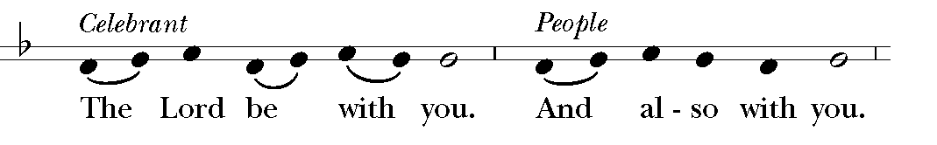
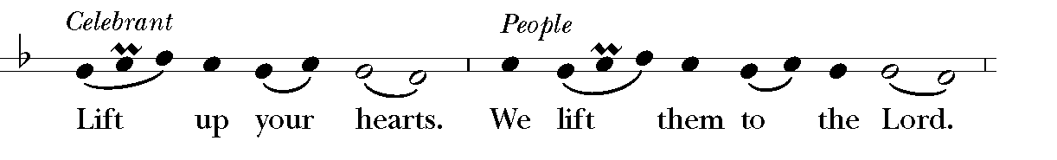
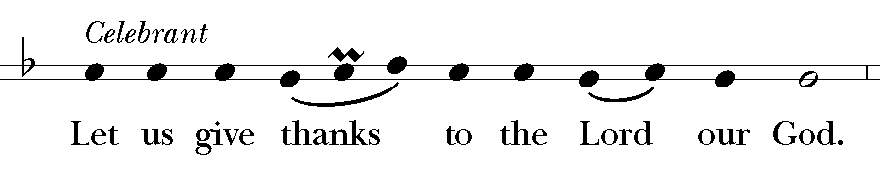
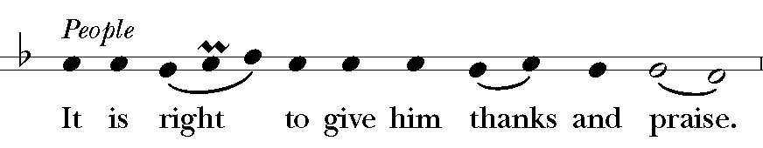

It is right, and a good and joyful thing, always and everywhere to give thanks to you, Father Almighty, Creator of heaven and earth. Through Jesus Christ our Lord. For our sins he was lifted high upon the cross, that he might draw the whole world to himself; and, by his suffering and death, he became the source of eternal salvation for all who put their trust in him. Therefore we praise you, joining our voices with Angels and Archangels and with all the company of heaven, who for ever sing this hymn to proclaim the glory of your Name:
Sanctus #125, The Hymnal 1982
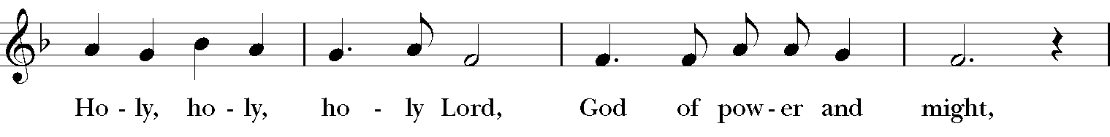
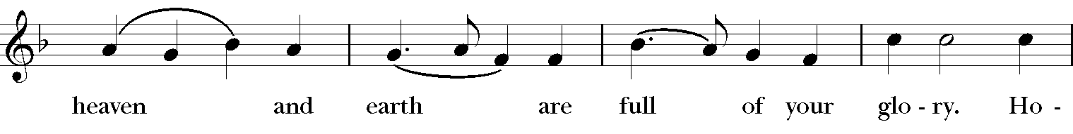
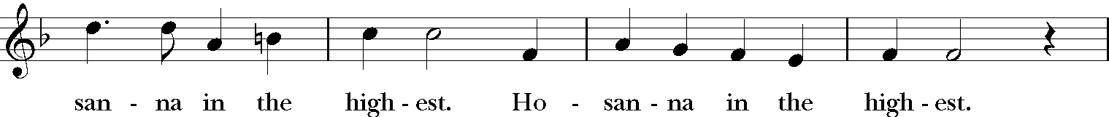
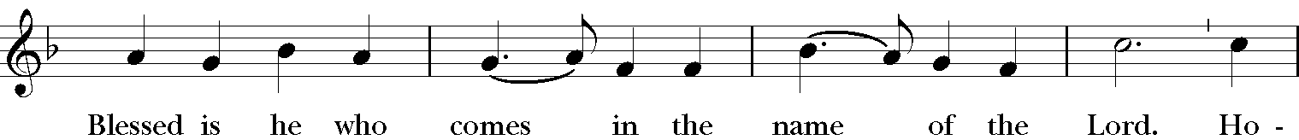
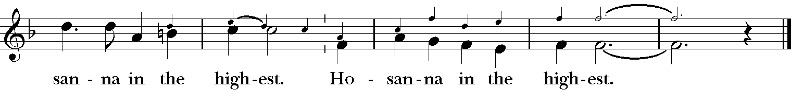
Music: From A Community Mass; Richard Proulx (b. 1937)

Celebrant: Holy and gracious Father: In your infinite love you made us for yourself, and, when we had fallen into sin and become subject to evil and death, you, in your mercy, sent Jesus Christ, your only and eternal Son, to share our human nature, to live and die as one of us, to reconcile us to you, the God and Father of all. He stretched out his arms upon the cross, and offered himself, in obedience to your will, a perfect sacrifice for the whole world.

On the night he was handed over to suffering and death, our Lord Jesus Christ took bread; and when he had given thanks to you, he broke it, and gave it to his disciples, and said, “Take, eat: This is my Body, which is given for you. Do this for the remembrance of me.”

After supper he took the cup of wine; and when he had given thanks, he gave it to them, and said, “Drink this, all of you: This is my Blood of the new Covenant, which is shed for you and for many for the forgiveness of sins. Whenever you drink it, do this for the remembrance of me.”

Therefore we proclaim the mystery of faith:
Celebrant and People: Christ has died. Christ is risen. Christ will come again.

Celebrant: We celebrate the memorial of our redemption, O Father, in this sacrifice of praise and thanksgiving. Recalling his death, resurrection, and ascension, we offer you these gifts.

Sanctify them by your Holy Spirit to be for your people the Body and Blood of your Son, the holy food and drink of new and unending life in him. Sanctify us also that we may faithfully receive this holy Sacrament, and serve you in unity, constancy, and peace; and at the last day bring us with all your saints into the joy of your eternal kingdom.

All this we ask through your Son Jesus Christ: By him, and with him, and in him, in the unity of the Holy Spirit all honor and glory is yours, Almighty Father, now and for ever.
S-147, The Hymnal 1982
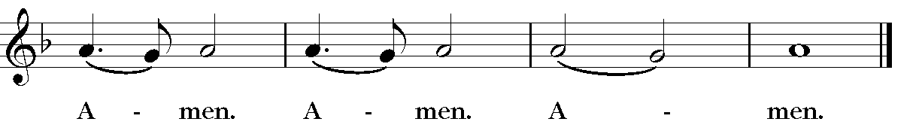
Music: McNeil Robinson II (b. 1943)

The Lord’s Prayer (Contemporary Version) S-148, The Hymnal1982
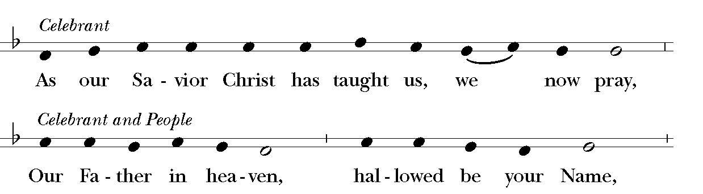
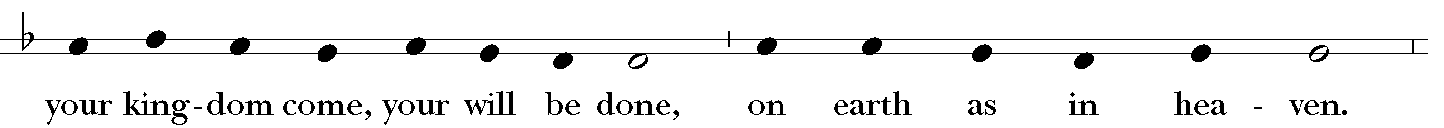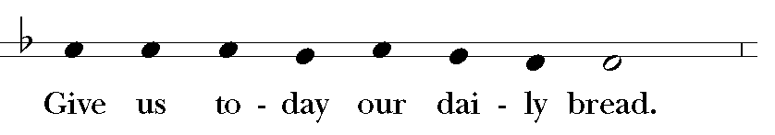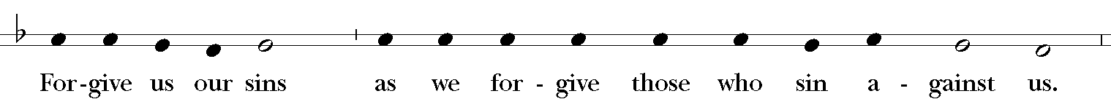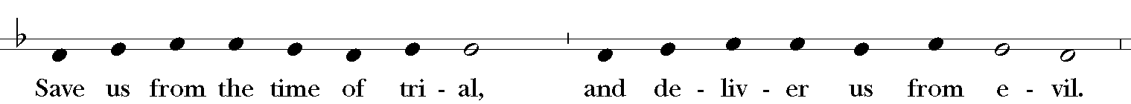
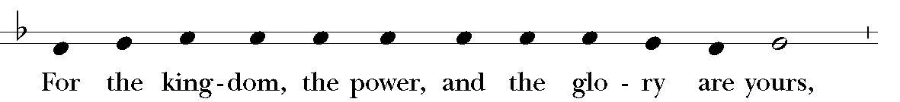
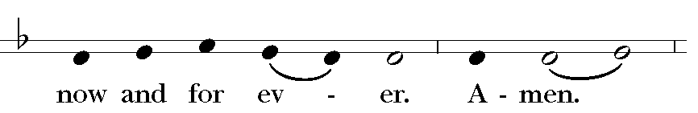 Music: Ambrosian chant; adapt. Mason Martens (1933-1991)

THE BREAKING OF THE BREAD [Action Three: Jesus Broke The Bread]
Fraction Anthem Be Known to us S-171, the Hymnal 1982
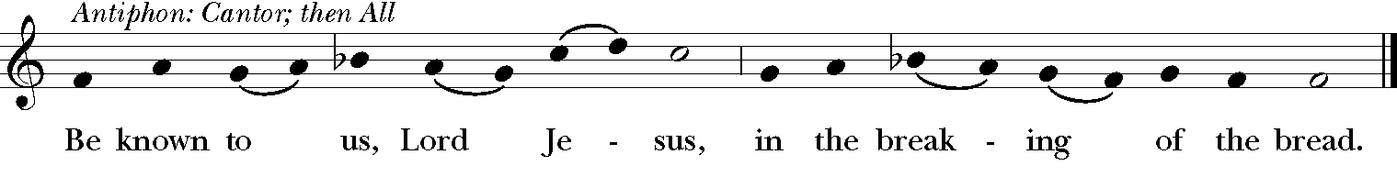
Music: Mode 6 melody; adapt. Mason Martens (1933-1991)

Celebrant: The Gifts of God for the People of God. Take them in remembrance that Christ died for you, and feed on him in your hearts by faith, with thanksgiving.

THE COMMUNION [Action Four: Jesus Gave The Bread & Wine]
(Those who are gathered in the parish church receive Communion on behalf of those participating electronically because of the pandemic.)

The Book of Common Prayer Assures of Full Spiritual Communion: “If a person desires to receive the Sacrament, but, by reason of extreme sickness or disability, is unable to eat or drink the Bread or Wine, the Celebrant is to assure that person that all of the benefits of Communion are received, even though the Sacrament is not received with the mouth.” (BCP, p 457)

A Prayer By Those Unable To Receive Communion Physically: Blessed Jesus, I believe that you are truly present in the Holy Sacrament, and, since I cannot at this time receive communion, I pray you to come into my heart. I unite myself with you and embrace you with all my heart, my soul, and my mind. Let nothing separate me from you; let me serve you in this life until, by your grace, I come to your glorious kingdom and unending peace. Amen.

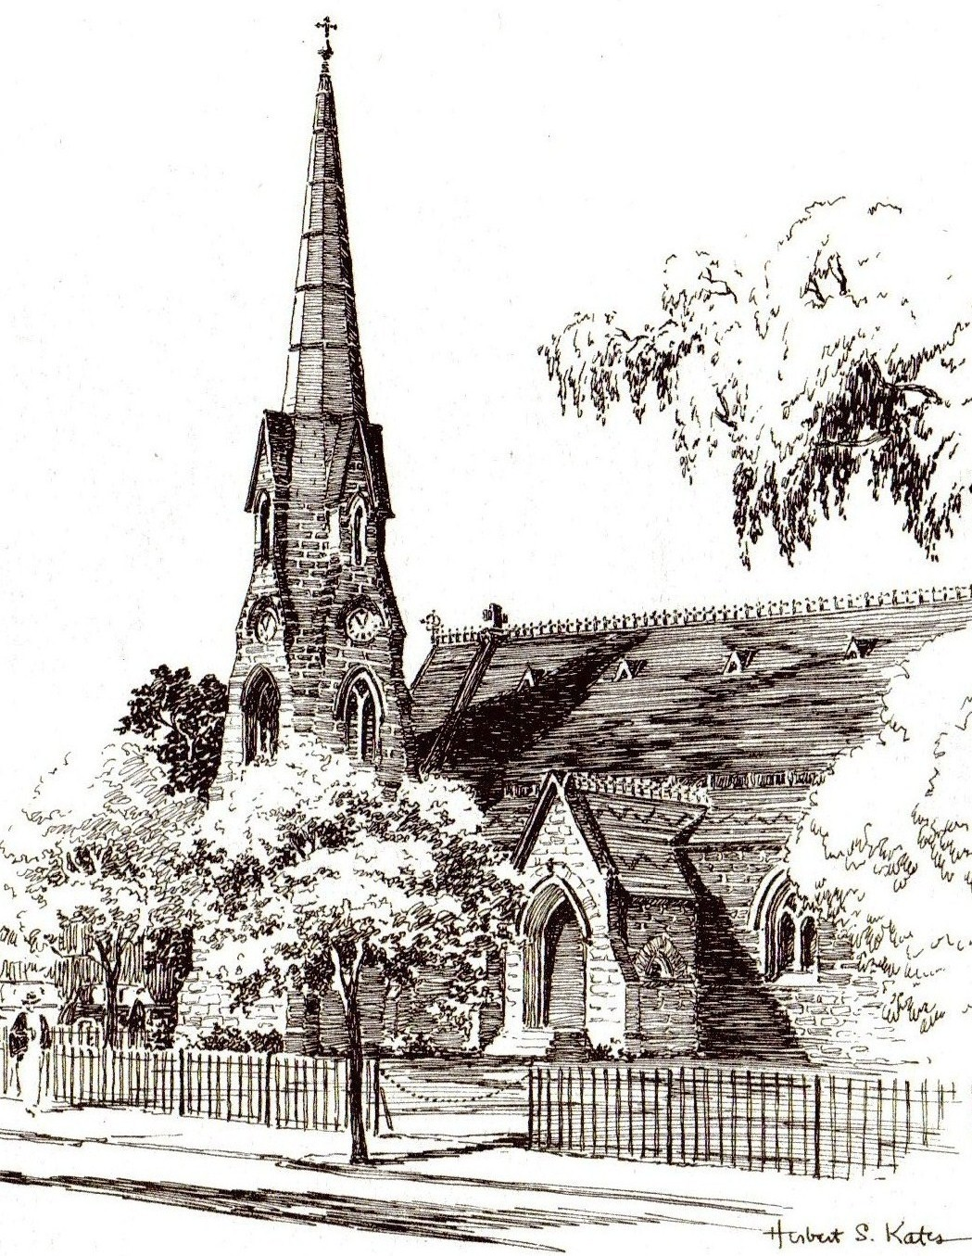

THE CONCLUDING RITE
We Are Sent Forth To Serve All People In Christ’s Name.

Post Communion Prayer
Celebrant: Let us pray.
Celebrant & People: Eternal God, heavenly Father, you have graciously accepted us as living members of your Son our Savior Jesus Christ, and you have fed us with spiritual food in the Sacrament of his Body and Blood. Send us now into the world in peace, and grant us strength and courage to love and serve you with gladness and singleness of heart; through Christ our Lord. Amen.

Blessing
Closing Hymn #473, The Hymnal 1982
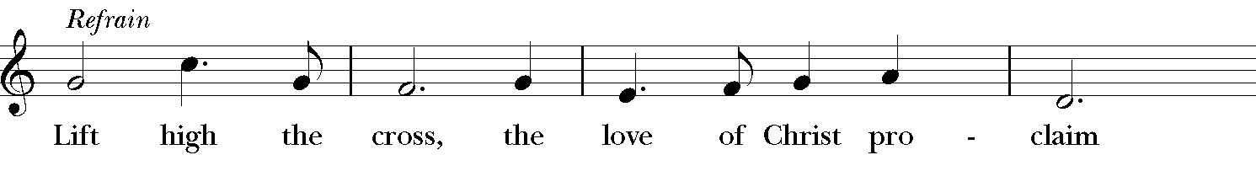
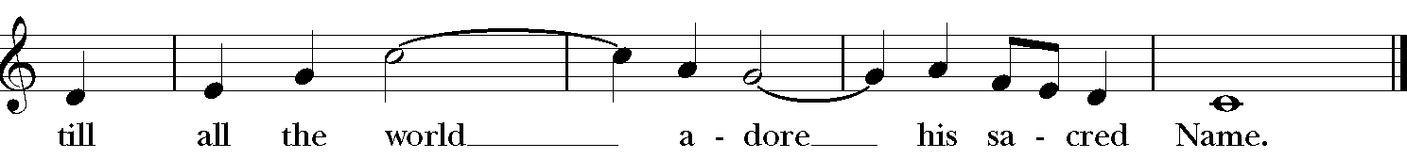
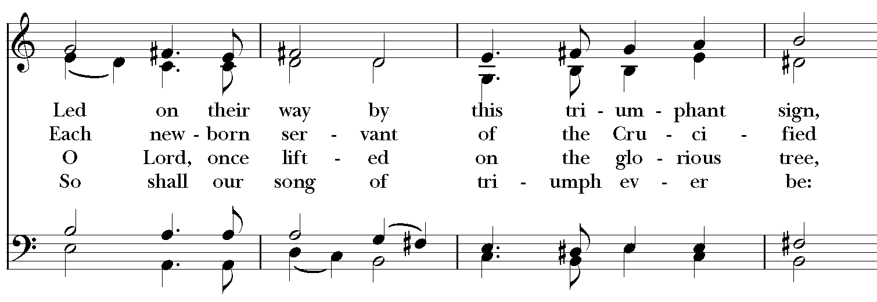
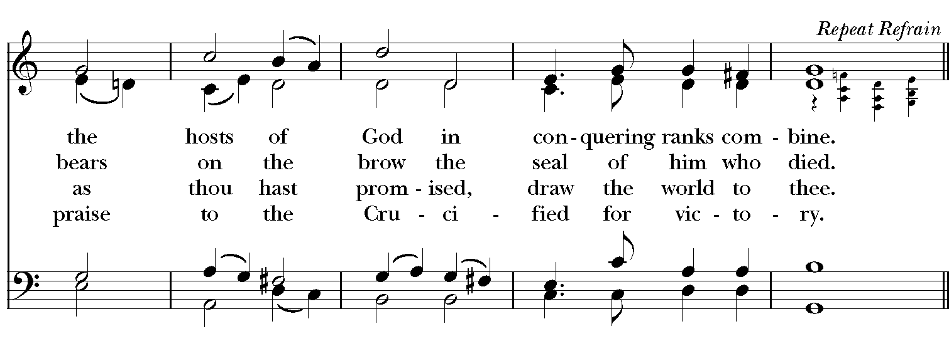
Words: George William Kitchin (1827-1912) and Michael Robert Newbolt (1874-1956)
Music: Crucifer, Sydney Hugo Nicholson (1875-1947); desc. Richard Proulx (b. 1937)

Dismissal: S-174, The Hymnal 1982
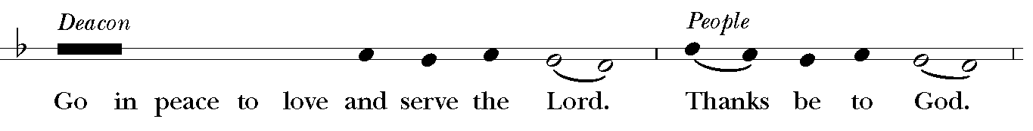

Organ Postlude

Celebrant & Preacher The Rev. Robert E. Gahler
Deacon The Rev. Hyacinth E. Lee
Organist & Director of Parish Music Philip Auman Godlewski
Trinity St. Paul’s Singers Robert Puleo (Tenor), Michael Hull (Tenor),
Philip Auman Godlewski (Baritone)
Lector Katrina Gomes
Intercessor Robert Puleo
Acolyte Sean Patrick Gahler Hull
Assistant Acolyte Olivia Moser
Ushers Sookie Eli, Pat Nelson
Video Joseph Pombo, Delano Allen

